**STEEP SLOPE STABILISATION IN ASSAM, NORTHERN INDIA**

**Shantanoo Bhattacharyya* and Paul Truong\*\***

* Coordinator, East India Vetiver Network

Email:[**<shantanoo.bhattacharyya@gmail.com>**](mailto:%3cshantanoo.bhattacharyya@gmail.com%3e)

** Director, The Vetiver Network International (TVNI) and

Veticon Consulting, Brisbane, Queensland, Australia

Email: **<**[**truong@uqconnect.net**](mailto:truong@uqconnect.net)**>**

**Abstract**

Lands and rivers in Assam in North Eastern India are exposed to and vulnerable to severe erosion due to its steep topography, highly erodible soil and torrential monsoonal rains.

Hard engineering works to prevent erosion have been attempted over decades in the region, incurring large financial and environmental costs, and with limited success. This in combination with limited State budgets makes finding an alternative, low cost, environmentally sustainable solution imperative. One such method that shows considerable promise is the Vetiver System (VS).

1. **INTRODUCTION**

Soil erosion is one of the largest environmental issues facing the earth today, and the North Eastern region of India in particular, with its heavy rainfall. Erosion devastates infrastructural activities: landslides, erosion by river and flood water take heavy toll of existing infrastructure.

Hard engineering works to prevent erosion have been attempted over decades in the region, incurring large financial and environmental costs, and with limited success. This in combination with limited State budgets makes finding an alternative, low cost, environmentally sustainable solution imperative. One such method that shows considerable promise is the Vetiver System (VS).

This paper presents the results to date of a series of VS applications in the stabilization of riverbanks and steep slope erosion protection in the region.

**2.0 RIVER BANKS STABILISATION**

All the sites described here are on river banks of the Brahamaputra River and its tributaries. The issues that arise here are:

* The highly erodible alluvial silts,
* The large range of the river between high and low water (often greater than 5m),
* The high silt load in the river
* The scarcity of hard rocks in certain areas for rock riprap.
* Extensive mining or rocks and river boulders have created environmental disasters.

The conditions are so severe that the river has in many places totally changed its course over night. In addition to the erosion caused by the flow of water, the river banks tend to slump when the water level in the river starts to recede after the floods. This is because the soils are relatively impermeable so that the pore pressures remain high; this causes the effective stress on the shear surfaces to be low, resulting in low shear strength.

The worst erosion occurs at the bends in rivers and this is sometimes made worse by man’s intervention with inappropriately applied hard erosion control measures or flow deflection works. The proximity of dwellings, religious shrines, flood embankments and tracks to the river banks sometimes makes trimming the river banks to the ideal slope of 1v:2h for pure vetiver impossible. Therefore, other slope stabilization measures were recommended to enhance the probability of vetiver’s success.

These additional measures included geogrids and coir mat laid on the surface. The coir mat provides addition erosion protection, whilst the geogrid provides additional restraint against the soil slumping. In addition, in some situations the toe of the slope is not exposed at low water level making planting of vetiver to protect the toe impossible.

Stone pitching of cobble filled baskets would normally be used in this situation, but because of the scarcity of the stone in Eastern Assam these are expensive and environmentally unsustainable options. The proposal is therefore to try to protect the toe with a flexible mattress of sandbags wrapped in geogrid. This mattress is laid in such a way that it takes the profile of the toe and extends about 2-3 m horizontally on the river bed. Low water level being defined as the lowest level at which vetiver will not be submerged for more than 4 months (Appendix).

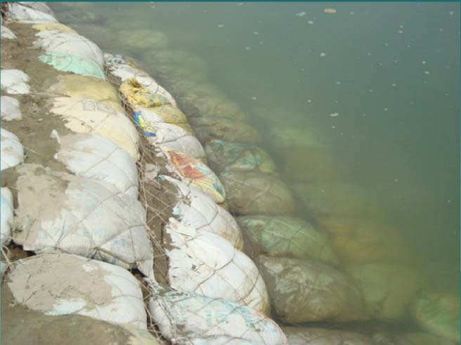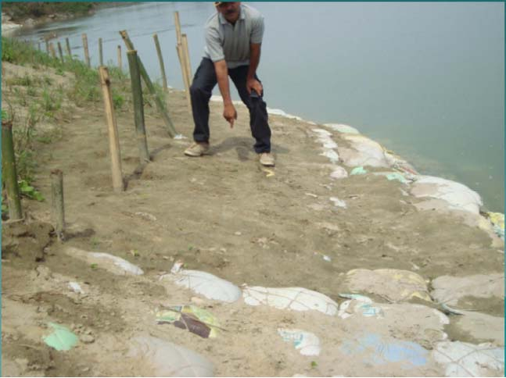

***Soil bag mattress held together by geogrid and silt deposition occurred during flood***

The use of reinforced concrete porcupines is common in the area. These consist of reinforced concrete members 3m long with a square section of 100mm. These members are provided with a number of holes at the third points so that the members can be bolted together to form pyramid shapes with protruding spikes. These pyramids are then joined together to form long strings, which are placed in the river to attract silt at strategic locations. An alternative design is to use bamboo to create a similar shape. The success of the porcupines seems to be mixed.

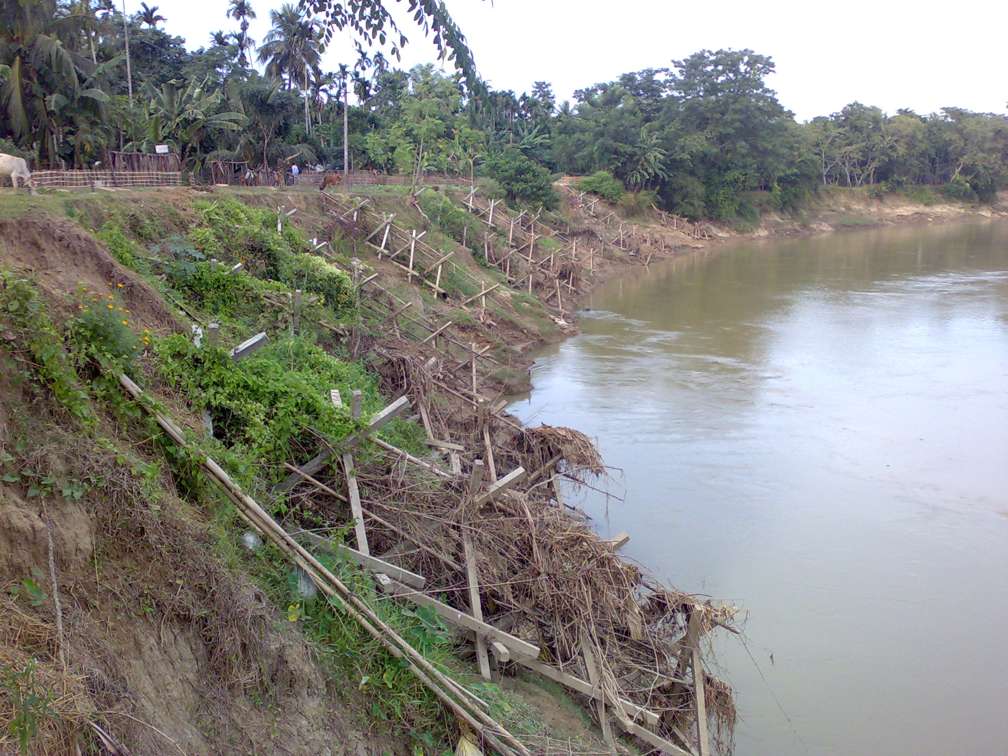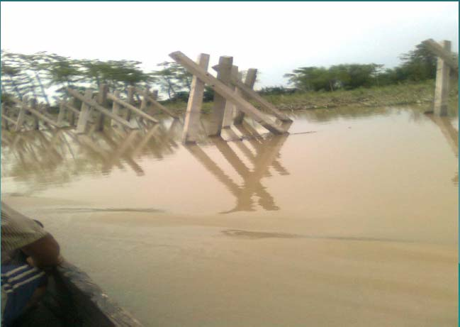

***Bamboo porcupines on the left and concrete porcupines under flood on the right***

**2.1 Vetiver works along the mighty Brahmaputra River**

The Brahmaputra is said to be the most difficult river to control in the entire world. National as well as international team of experts have studied this river for the last 50 years without being able to give any solution to control the erosion of the mighty Brahmaputra.

Erosion due to fluvial scouring as well as due to sloughing occurs. The former occurs naturally during the rainy season/flood season in the summer. Sloughing takes place in the winter when the water level goes down and the bank collapses.

The project site is a stretch of about 500m, and the bank height during the winter was a massive 6-7m. The bank profile was almost vertical; at some places it was concave with sandy soil with severe erosion.

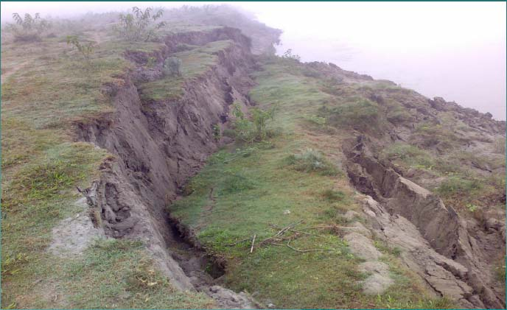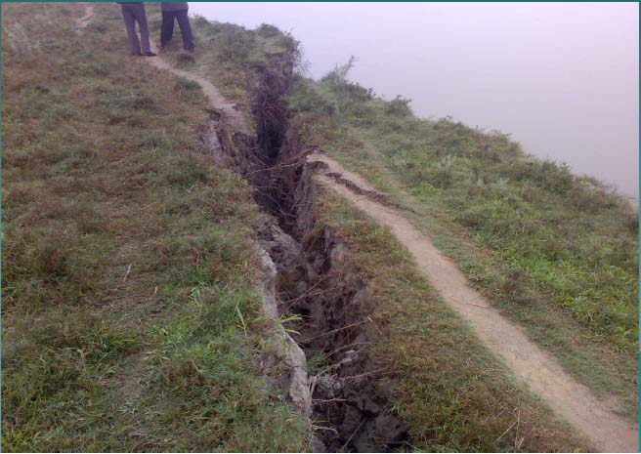

***The banks are highly unstable due to strong current and erosion at the toe of the slope***

The bank was trimmed to a gradient 1V: 2H. Planting was started on 28/2/2010 and was done in grid pattern with the distance between rows parallel to river flow being 1m and between the rows normal to the river flow 2m. Planting density was 10/m starting for the low water mark.

No irrigation as the rains started before planting was finished. Slowly the water level began to rise. Thus immature plants got submerged. In fact they remained submerged with little hope of survival. Two months after planting, the entire area was totally submersed.

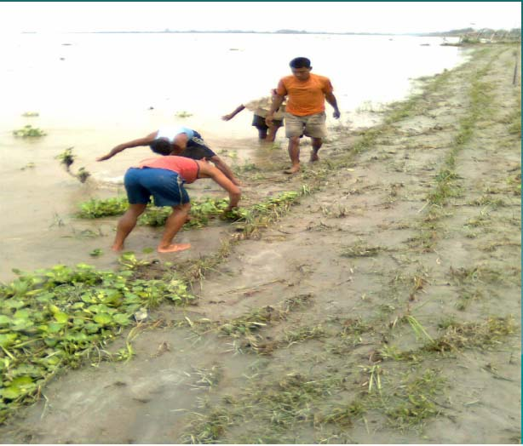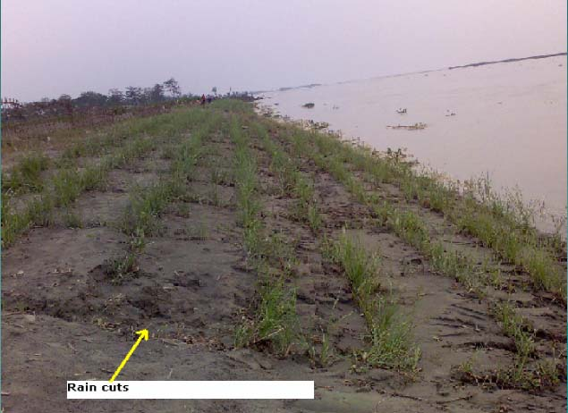

***Flooding damaged new planting but fully recovered after repairs and weed removal***

Since then there was total submergence on at least 5 other occasions. Water receded in between exposing about 3-4 rows (out of 12 rows parallel to the river flow along the slope).

**2.2 Vetiver works along Kapili River**

Vetiver was planted on 3 sites along the Kapili River. It is a big tributary of the Brahmaputra. The bank was very steep and there were houses on top. The locals did not want the slopes trimmed so it was necessary to plant the vetiver on slopes of 45 to 70°. The slope was also irregular in all dimensions.

A 1m x 1m grid measured on the slope was planted, but not on some patches which were 90 deg steep, DAP fertilizer and cow manure were used. Some cracking was visible behind the crest line but there were no open cracks and no bank retreat had occurred over the monsoon period. Porcupines were at about 15m spacing over some portions. The river was in flood at the time of this visit with a rise of 3m reported by villagers. The vetiver appeared to be growing well except where cultivation at the crest of one area was encroaching on the first vetiver rows. Some trimming was needed soon now that the monsoon season was almost over. Hopefully once the local people are convinced of the benefits of vetiver they will take ownership of the maintenance requirements.

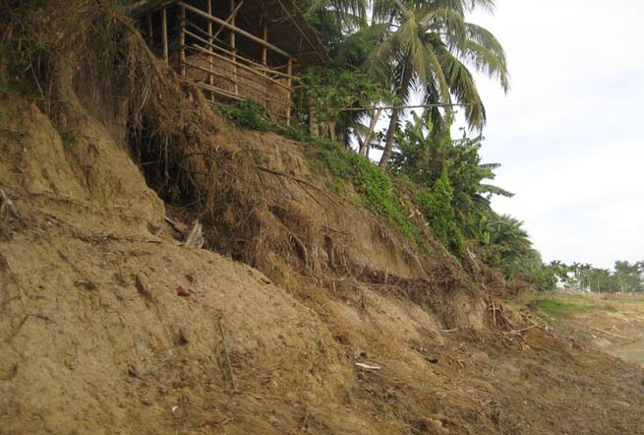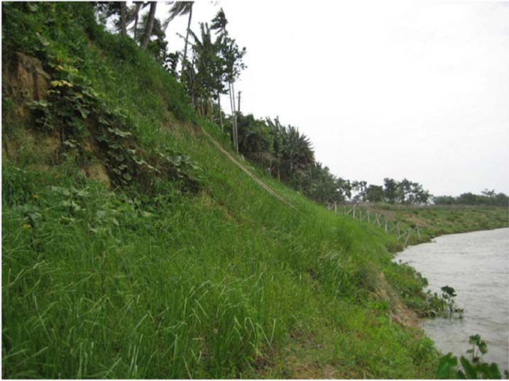

***Before and after vetiver planting on a very steep bank of the Kapili River***

All the 3 sites were successful and still there was no erosion after the flood season. It was noted that vetiver attracts other vegetation and sometimes get overwhelmed.

**2.3 Vetiver works along Kolong River**

The Kolong River, a major tributary of the Brahmaputra eroded severely at Telahi. This was the first project, on a stretch of about 470 m. The slope was quite steep so any trimming of the slope would have cut into an embankment which was already eroding.

The planting was done in 1mx1m grid. Plant to plant distance was 15 cm. There was toe erosion also. But the Water Resources Department, Government of Assam , under which the work was done did not care to protect the toe. However the project was a success as shown in the photographs. But on the second year, it is reported that there is some erosion at the toe and consequently a section failed and to be assessed later. But it was quite predictable as no measure was taken to control erosion at the toe and underwater.

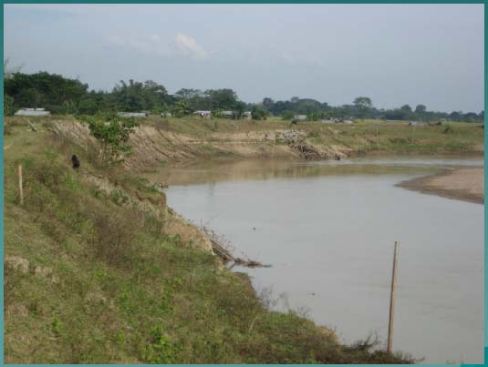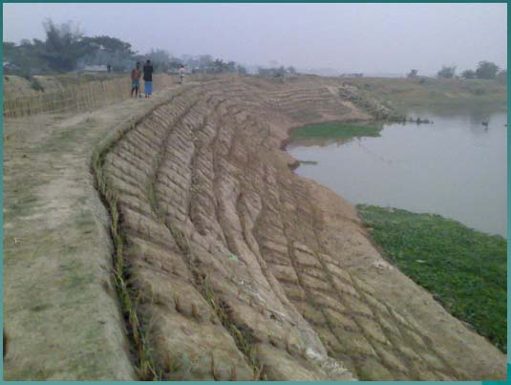

***Highly erodible banks of the Kolong River, including undercut toe erosion***

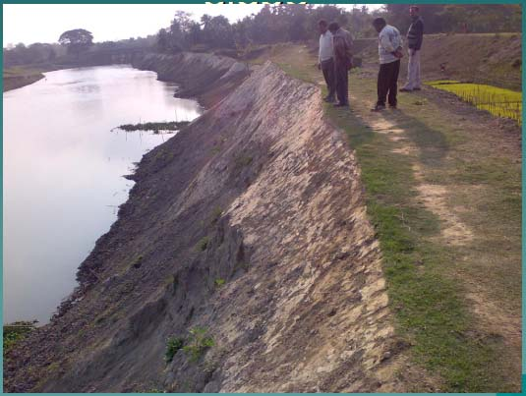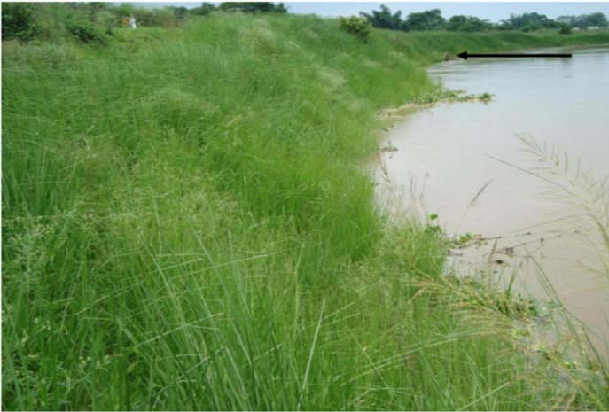

***Before and after vetiver planting on a very steep bank of the Kolong River at Tilahi***

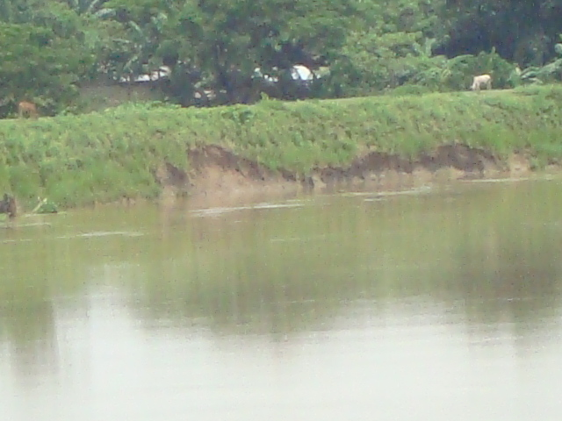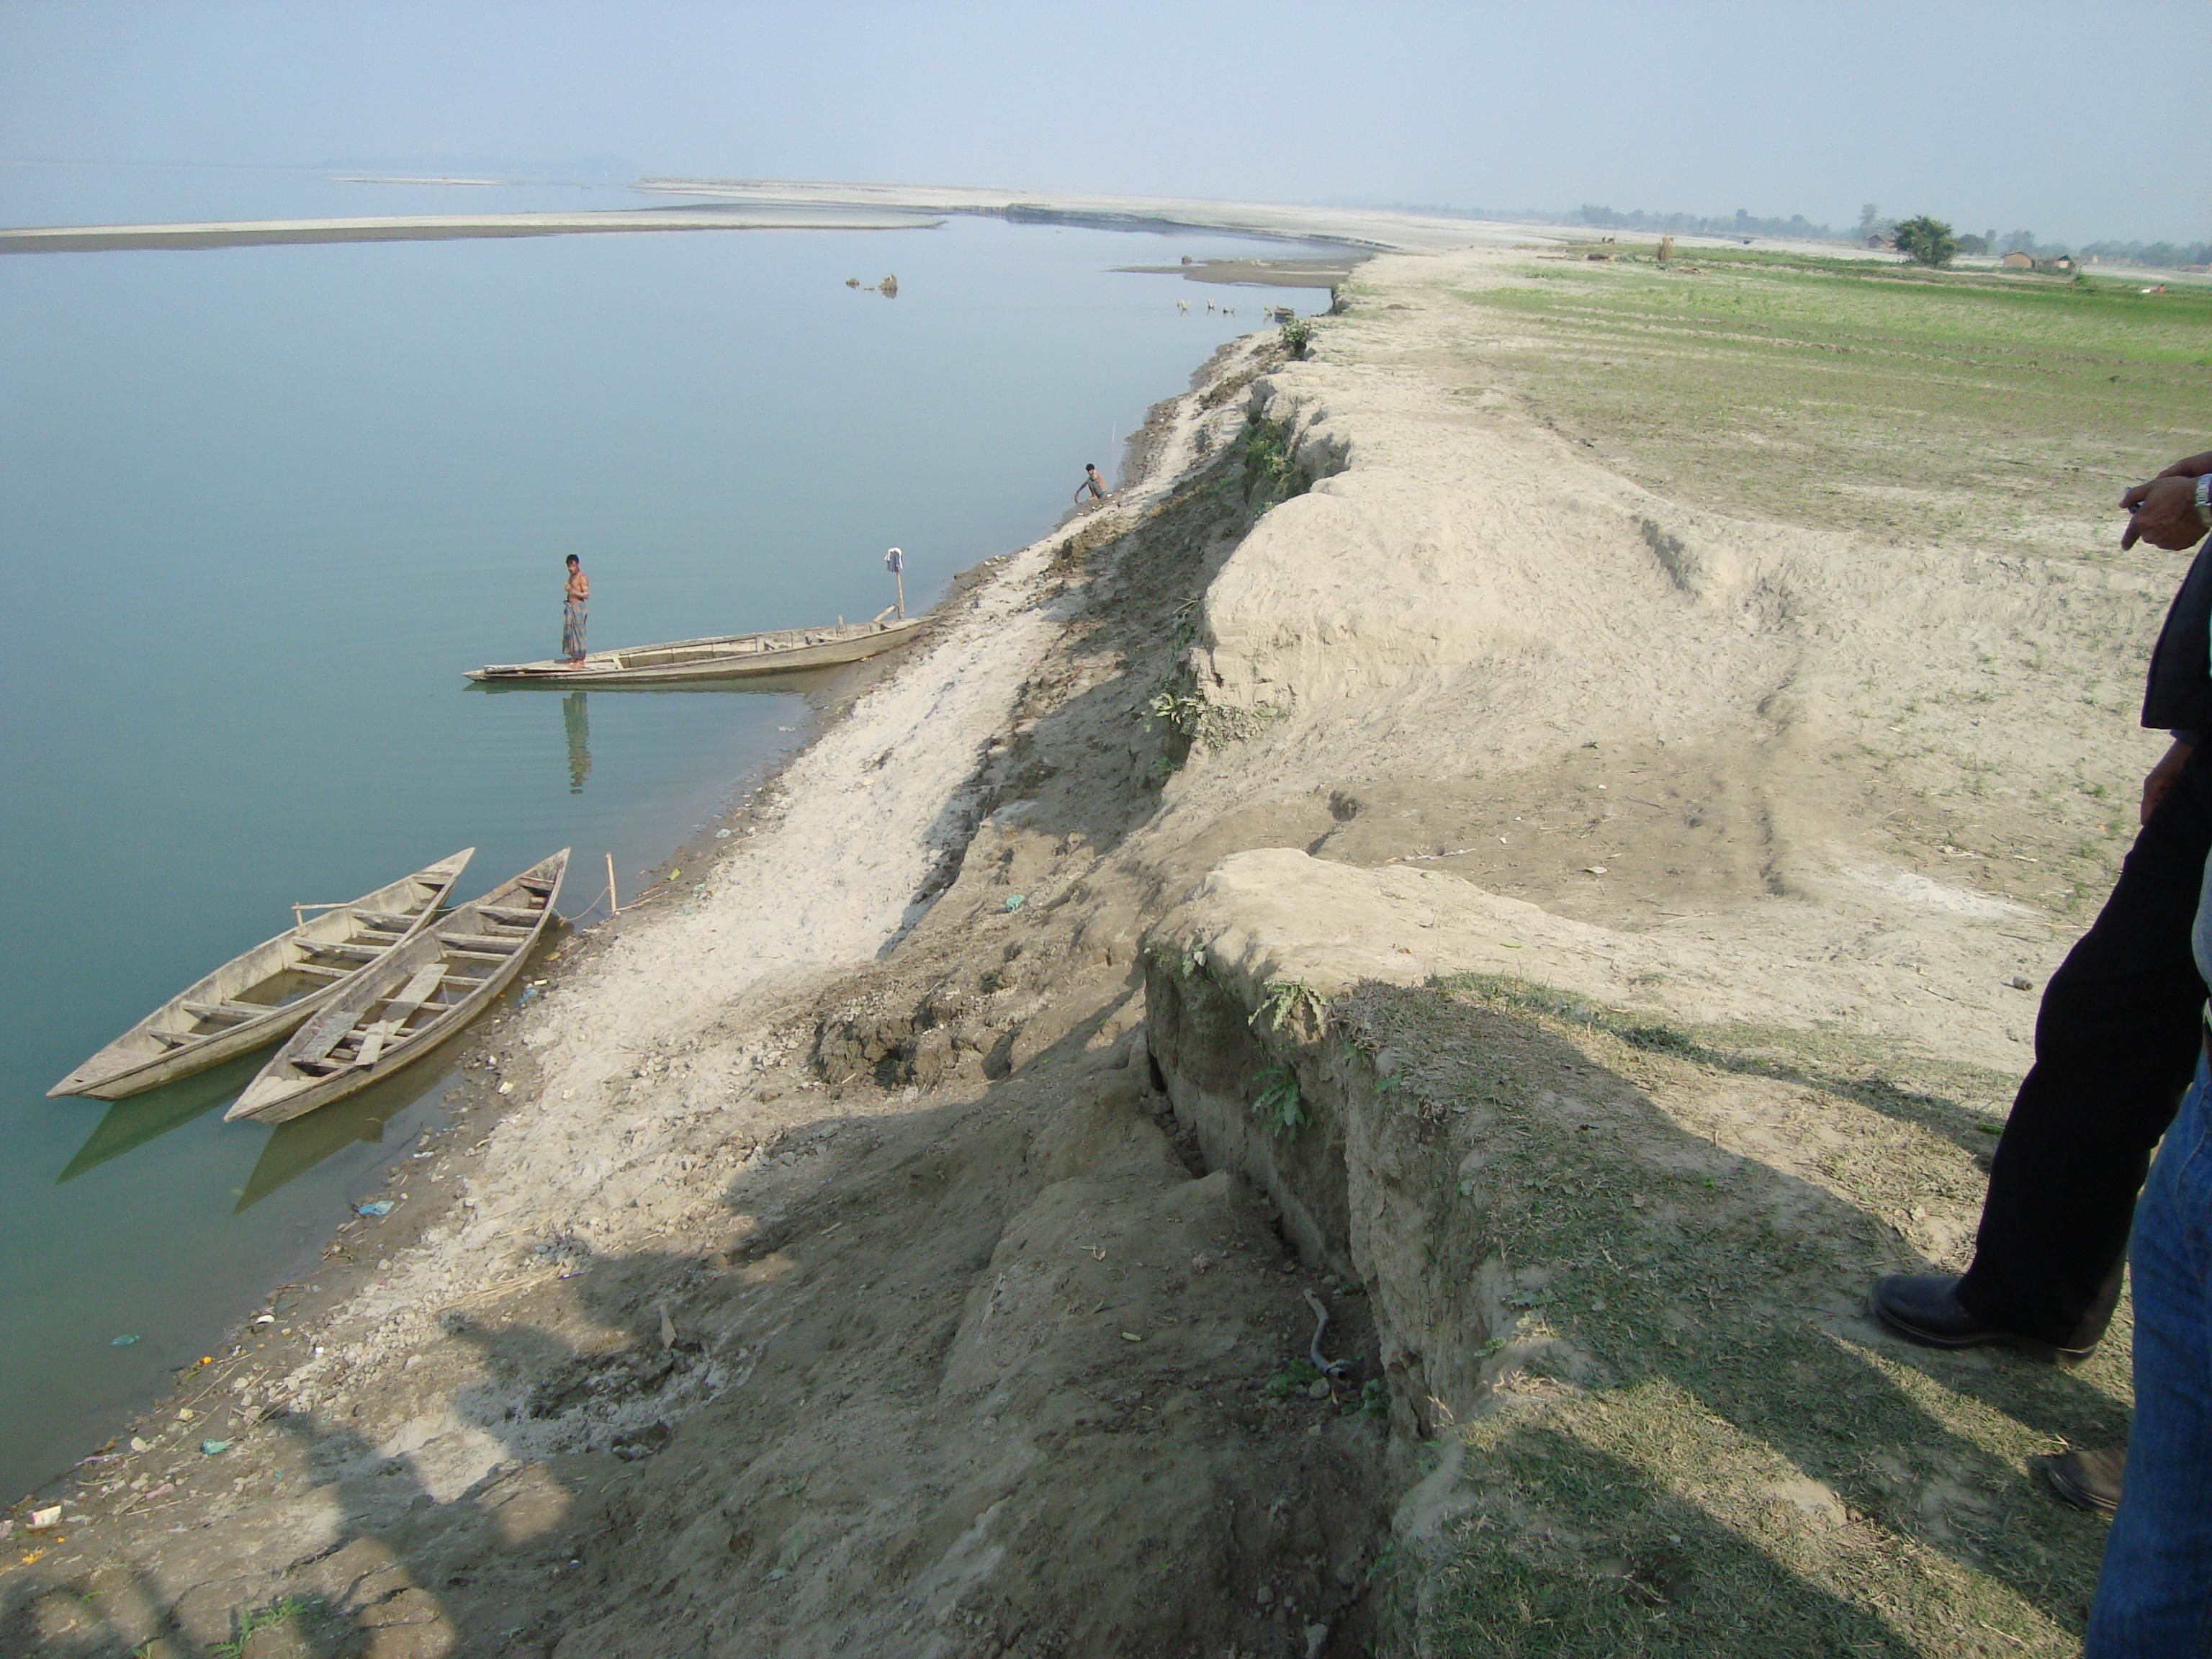

***Typical undercut at toe of banks***

**2.4 Vetiver work in Majuli : Doria bridge approach**

The protection work of the Doria Bridge was a very prestigious project. The Commissioner of Public Works Department himself requested this work. The location of the work was very vulnerable to erosion. The bridge is constructed over a wetland. Flood water of the Brahmaputra enters the wetland and flows through it. The soil used for the construction was very sandy with little cohesion. The construction procedure was also very poor. After the formation height of the approach was attained in the core, the side slopes were built up simply by dumping fill material; with no compaction hence the slopes were not at all consolidated. The vetiver planting started from 3rd April, 2010. The rainy season started early this year. Hence, the plantation work had to be done during heavy rains. We had to face lot of problem tackling rill and surface erosion and soil slips. Sand bags and bamboo palisades had to be used to control these problems. Eventually, the entire upstream slopes on both approaches and some parts on the downstream slopes were completed with vetiver planting.

Plants raised in polybags were used and planted in 1m x 2m grids at 10 cm apart. This has been a great success.

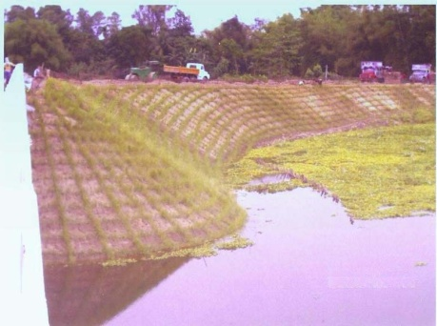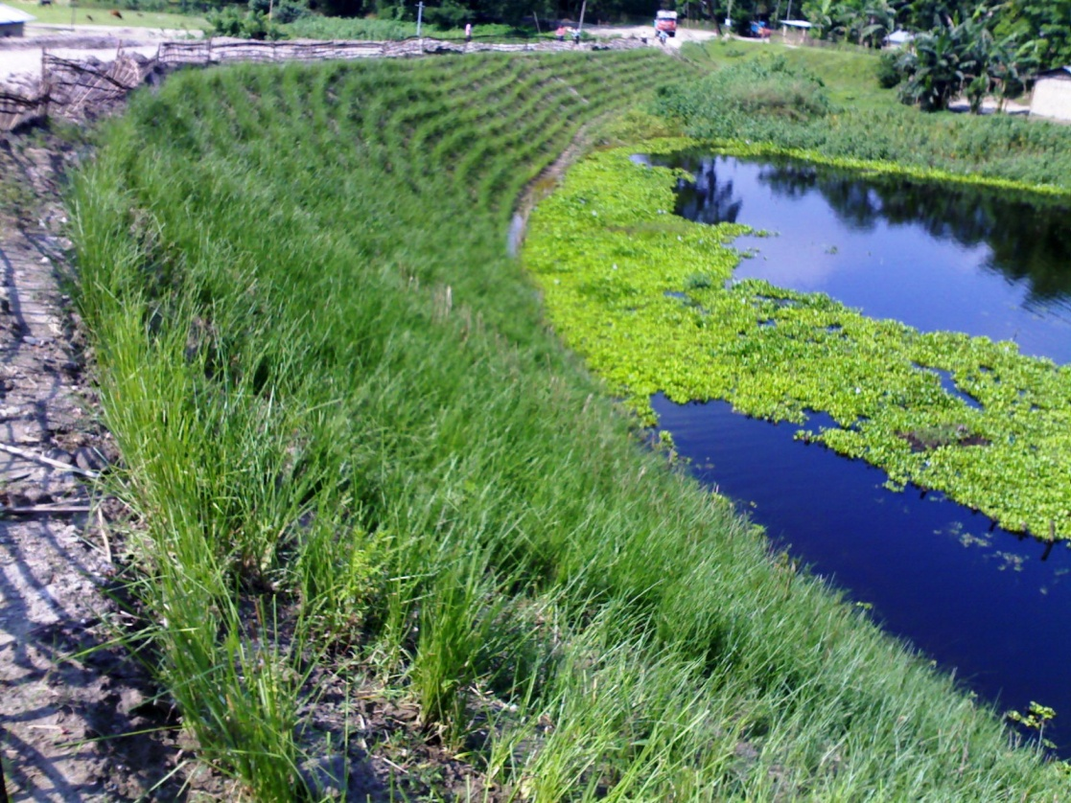

***Three weeks and three months after vetiver planting at Doria bridge approach***

**2.5 Vetiver work along rivers Na- Dihing**

The Na- Dihing river is a big tributary on the upper reaches of the Brahmaputra. The locations- Pawoi/ Chumoni experienced severe erosion, both fluvial and sloughing. Also there was great underwater erosion on the toe of the bank. So unless the toe erosion/scouring of the bank is properly handled, it will be futile to go for any protection on the bank slope.

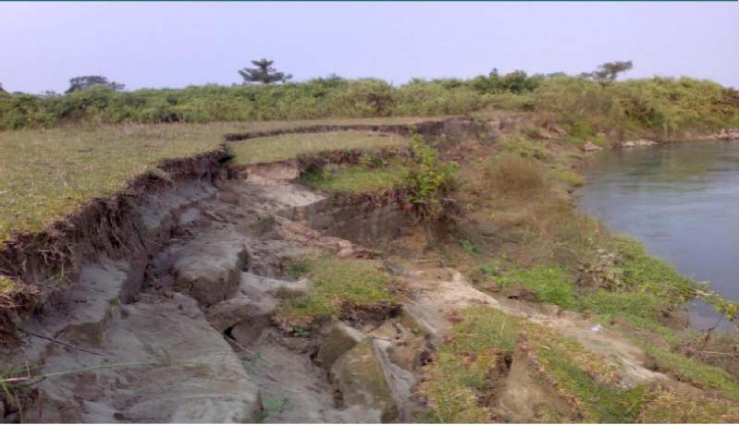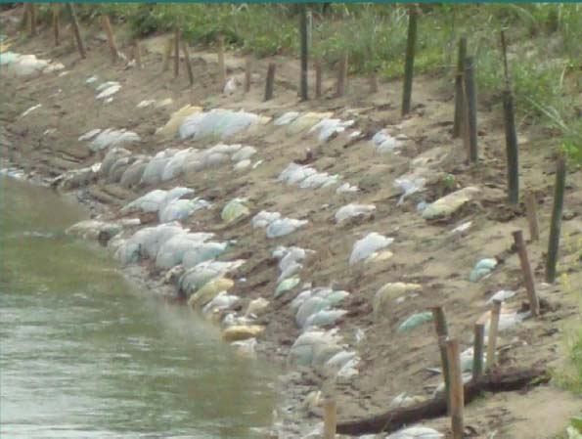

***Severe erosion due to strong current and undercut Bamboo stakes pinning down mattress***

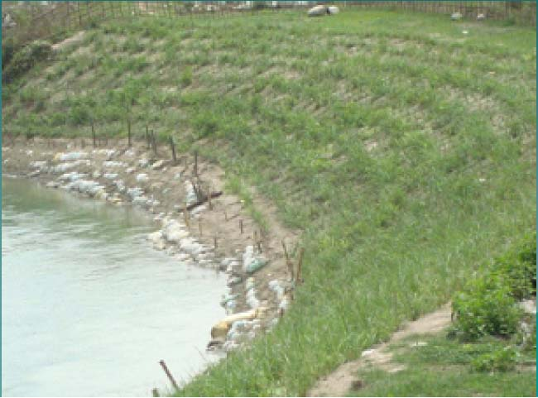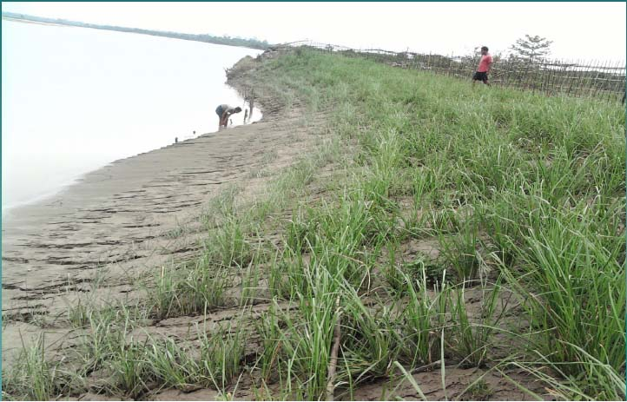

***The bank has been successfully stabilized and silt deposition occurred at the toe of the bank.***

Hence a flexible mattress was designed. It was made of empty cement bags filled with sand and nylon net, 125mm mesh. The mattress was stitched around each bag so that the entire mat remained as a mattress – not forming a lump. The mattress was laid out about 5 m into the river bed. And was pinned to place with the help of bamboo stakes.

Above the low water level, the bank was trimmed to 1V: 2H and vetiver was planted in 1m x 2m grids at density of 10planta/m. The vetiver plants encountered flood within a month of planting. The first flood generally carries lot of sediment. Our effort attracted lot of sediment and the sandbag mattress gradually got buried.

This project is a unique success as it received government officials’ ridicules initially.

You can see the bank gradually sloping down. There was silt deposition at the toe of the bank.

Interestingly the velocity of flow near the bank went down from about 2m/sec to 1.1m /sec. The sand bars which formed on the other side have now been eroded by the river. Hence, it seems the river is straightening.

***It was heartening to find that the local communities submitting petitions to the Govt. of Assam to go for the vetiver technology for erosion control. This is our certificate of success*.**

**3.0 STEEP SLOPE EROSION PROTECTION**

**3.1 Vetiver works on Navagraha Hills.**

The first vetiver demonstration site for hill slope was selected within the city of Guwahati- the northern slope of Navagraha hills. The site, about 65m x 27m, was characterized by sandy clay with pH value of 6.

The gradient was 400 on an average. The slope was not modified; no bench was cut as the site offered little scope for modification.

Planting was carried out in December 2008 and the condition of slope monitored before, during and after the monsoon season in 2009.

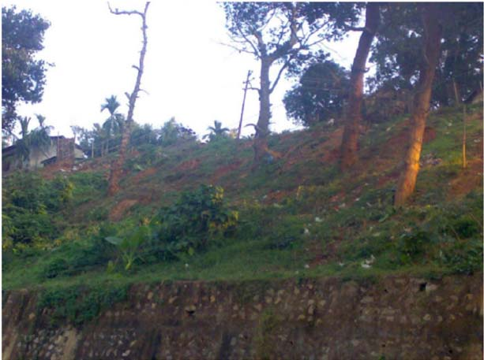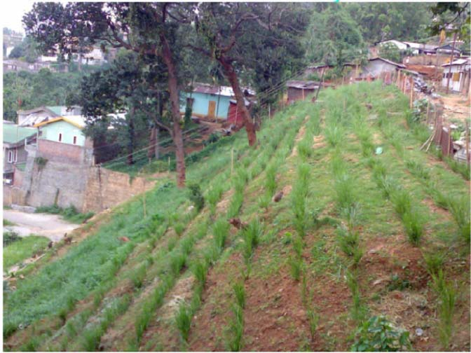

***The site before and after vetiver planting on Navagraha Hills***

**3.2 Vetiver work in Noonmati, Guwahati**

A stretch of 150 m was taken up to demonstrate ability of vetiver to prevent landslide, and arrest of sediment flow down the hill slope. The Guwahati city is surrounded by hills. The hills are getting bare because of population pressure. The drains get clogged during rains and water logging is a big problem. The roads become muddy.

The slope of the project area was not uniform varies from 400 to about 650. No major trimming was resorted to as hill cutting is ***officially*** banned*.*

It is a huge success so far and The Indian Oil Corporation Ltd, which sponsored this project is very satisfied with the results.

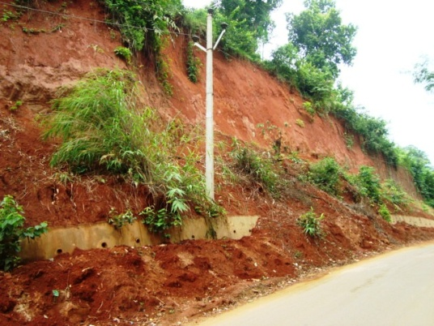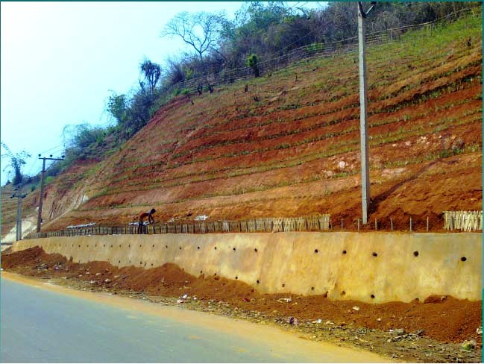

***The site before and after vetiver planting at Noonmati***

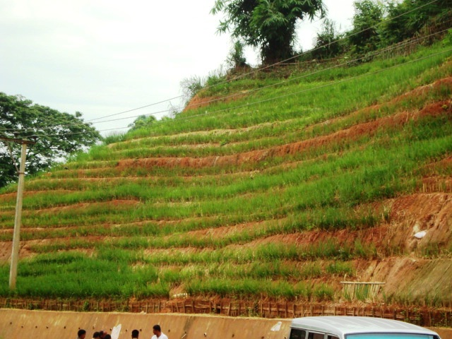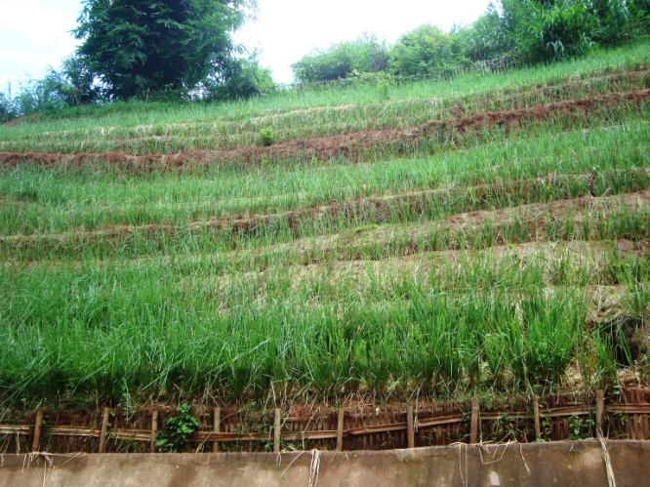

***The site two and three months after vetiver planting at Noonmati***

**No vetiver**

**Vetiver Planting**

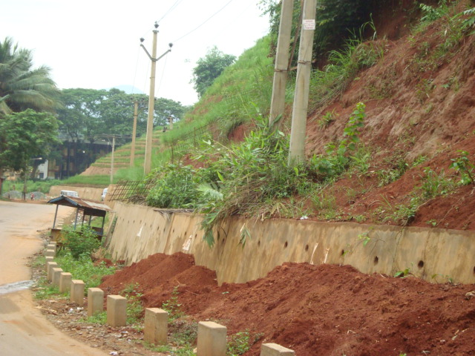

***Note the difference between sections with and without Vetiver planting.***

***Section without vetiver (left) experiencing land slide***

**3.3 Vetiver work in Sikkim**

Sikkim is a hilly state of India. Located in the foothills of the Himalaya, it has huge landslide problem. The Department of Rural Developments, who builds rural roads, requested us to do a demonstration project in south Sikkim where the climate is warm. This particular project area had some problems:

* water scarcity
* poor soil- full of gravels , see photographs

Plants were raised in polybags before taking to the field. But the soil did not have any cohesion. So we decided to keep the poly bags after removing / cutting open the bottom. May be this is the reason why the plant health was not vigorous. We used water tanker to bring water for irrigation.

After the rains started, vetiver started growing better. It is now more than 2 months into the rainy season, there is no slip in this site. Nearby landslips occurred- where there is no vetiver.

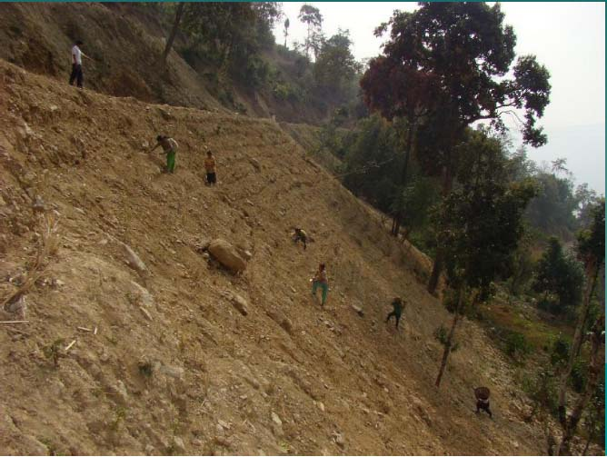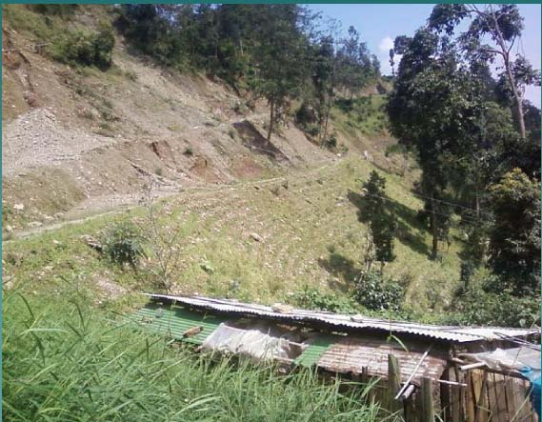

***The site before and after vetiver planting on a very steep with poor soil at Sikkim***

**4.0 ACKNOWLEDGEMENT**

The authors wish to thank Dick Grimshaw, Chairman of The Vetiver Network International for his support and encouragement on the works reported in this paper.

We also acknowledge the contribution of Oliver Hawes, Consultant Geotechnical Engineer, England, whose “Report on Visit to North Eastern India October 2009” to the Eastern India Vetiver Network was partly used in this paper.

**5.0 APPENDIX (** Proposed designs by of Oliver Hawes)

**Slope Trimmed 1V:2H and Toe of Bank not Exposed**

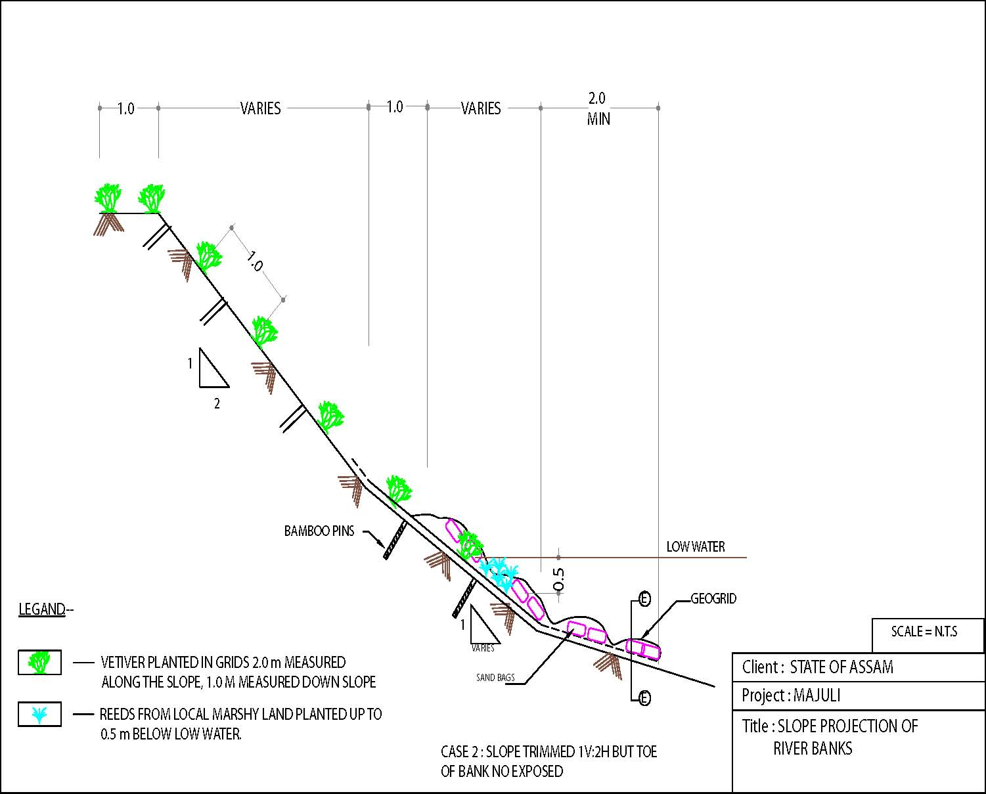

**Slope cannot be Trimmed to 1V:2H and Toe of Bank not Exposed**

